### Browser Compatibility testing

|  |  |  |  |  |  |
| --- | --- | --- | --- | --- | --- |
| No. | Test Title | Pre-Condition | Test Steps | Expected Results | Actual Results |
| 01. | Browser testing in Google Chrome. | Opening the system in the testing browser | logging in to the system | The test result was as expected. | As expected. |

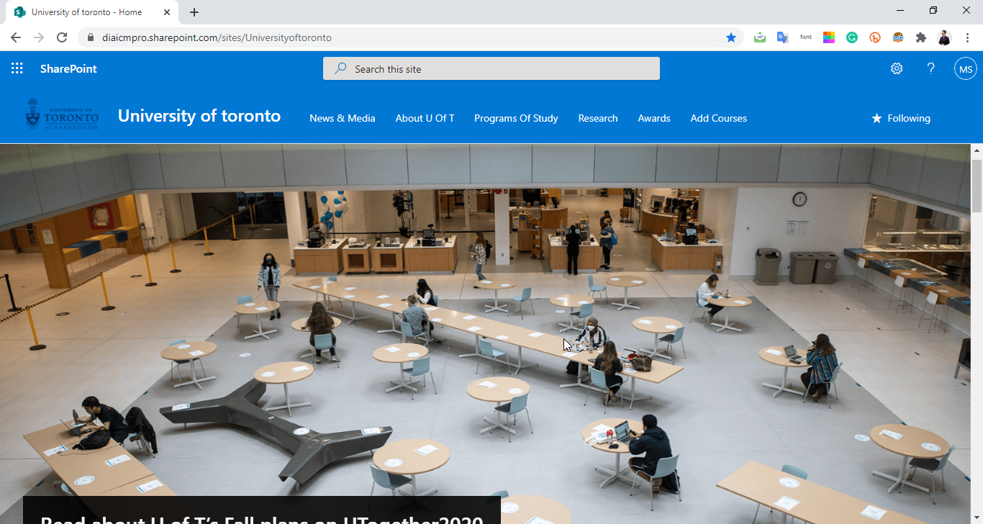

|  |  |  |  |  |  |
| --- | --- | --- | --- | --- | --- |
| No. | Test Title | Pre-Condition | Test Steps | Expected Results | Actual Results |
| 02. | Browser testing in Mozilla Firefox | Opening the system in the testing browser | logging in to the system | The test result was as expected. | As expected. |

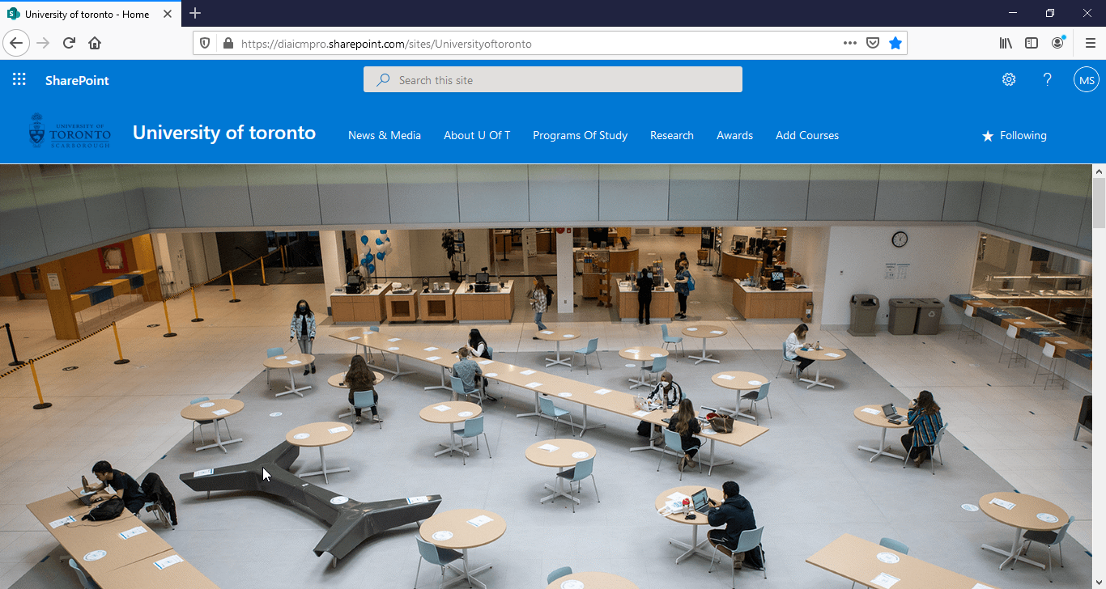

|  |  |  |  |  |  |
| --- | --- | --- | --- | --- | --- |
| No. | Test Title | Pre-Condition | Test Steps | Expected Results | Actual Results |
| 03. | Browser testing in Microsoft Edge. | Opening the system in the testing browser | logging in to the system | The test result was as expected. | As expected. |

